**Document Management (DM)**

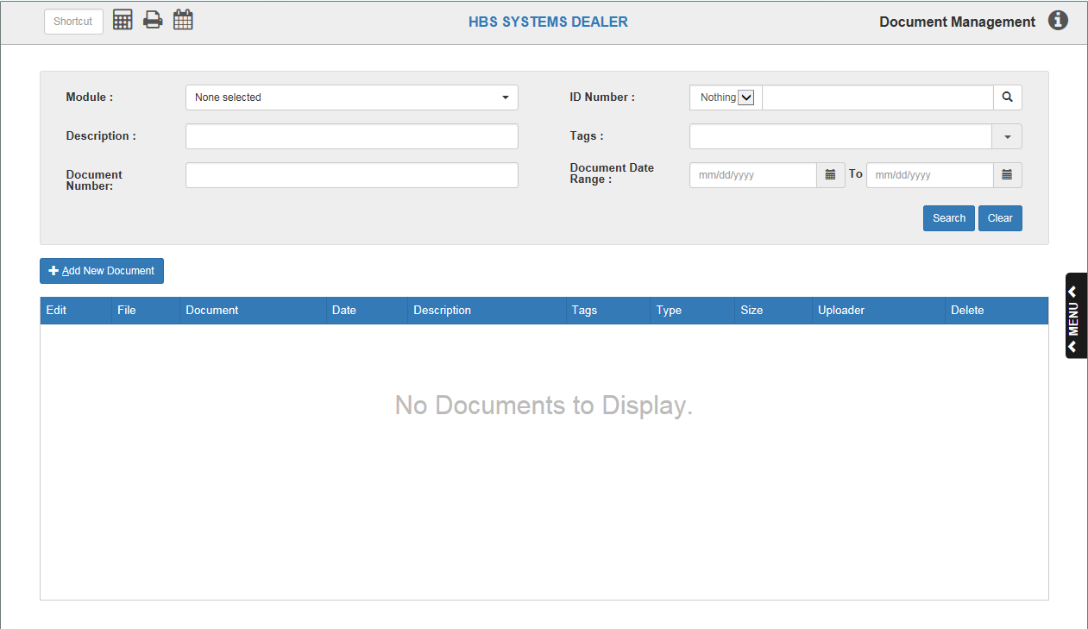

Document Management (DM) allows you to add electronic documents (eDocs) to NetView applications or edit preexisting documents. These can include Word documents, image files, PDFs, etc.

* To access this program, you can either:
  + Select “Document Management” from the menu and click either “Document Maintenance” or “Document Review.”
    - **NOTE:** The only difference between these is that clicking “Document Maintenance” will open Document Management with an “Add New Document” window already open (see “Add New Document” below).
  + Type “DM” in the Shortcuts Bar.

**Add New Document:** Click this button to add a new file to a NetView application from another location on your computer.

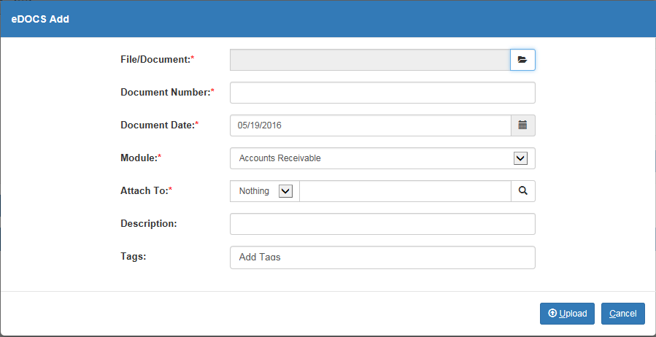

File/Document: Click the “Browse” icon to the right of the field to select the desired document to upload.

Document Number: Type the Document Number in this field.

Document Date: The field pre-fills with the current date, but you can change it if desired. Type the Document Date in this field or use the calendar icon to select a date.

Module: Select the NetView module to associate the file with. For example, if you are adding a rental contract, you would probably select “Rental” in this field. Likewise, if adding a service invoice, you would probably select “Service.”

Attach To:

* Choose an identification to attach the document to. This will change depending on the module. For example, if you are uploading a document to the Accounts Receivable (AR) module, you can attach the file to a particular customer number. Likewise, if you are uploading the document to the Inventory module, you could attach it to a part number or a POS invoice number.
* Once you have chosen the type of identification, type the relevant number in the field or use the Search button to look it up. Type in identifying information about the number, then choose the relevant entry from the search results that appear.

Description: This optional field lets you add a description to the document. For example, if the file is an image, you can type “Picture” in this field.

Tags: Tags are another optional method of identifying the document’s properties. Type in this field to add one or more tags that apply to the document. For example, if the document is an invoice, type “Invoice” here to create an identifying tag.

* As you type, a drop-down menu in the field will display similar tags that have already been applied to documents in the system. If you see that your desired tag already exists, select it from the menu to add it to your document.
* If the tag does not already exist, simply type it in the field and press “Enter.”
* To remove a tag from the document, click the small “x” on the right side of the tag.

Upload: Click this button to upload the document to NetView.

Cancel: Click this button to cancel your document upload.



**Search Fields:** These fields provide you with search criteria to help you locate a file for review that has already been uploaded to NetView.

Module: Use the drop-down menu in this field to select one or more modules to search in, up to all ten available.

* If you want to search documents from all ten modules, click “Select All.”
* The modules available to this program are:
  + Accounts Receivable
  + Customer Relationship Management
  + Inventory (Parts)
  + Accounts Payable
  + Units
  + General Ledger
  + Payroll
  + Service
  + Rental
  + Purchase Order

Description: Type in part or all of a document’s description to search for it.

Document Number: Type in part or all of a document’s number to search for it.

ID Number:

* If you are searching for a document within a single module, use this field to select the type of ID Number you want to search for and enter the number in the field.
* You can also search for the specific number using the Search button. Type in identifying information about the number, then choose the relevant entry from the search results that appear.

Tags: Type in the name of a tag or choose one from the drop-down menu to search for the document by its tags.

Document Date Range/To: To find a document located in a specific date range, type the starting and ending dates of the range in these fields. You can also look up the dates using the calendar icons attached to each field.

Search: Click this button to generate search results based on your chosen criteria.

Clear: Click this button to clear all the search fields.

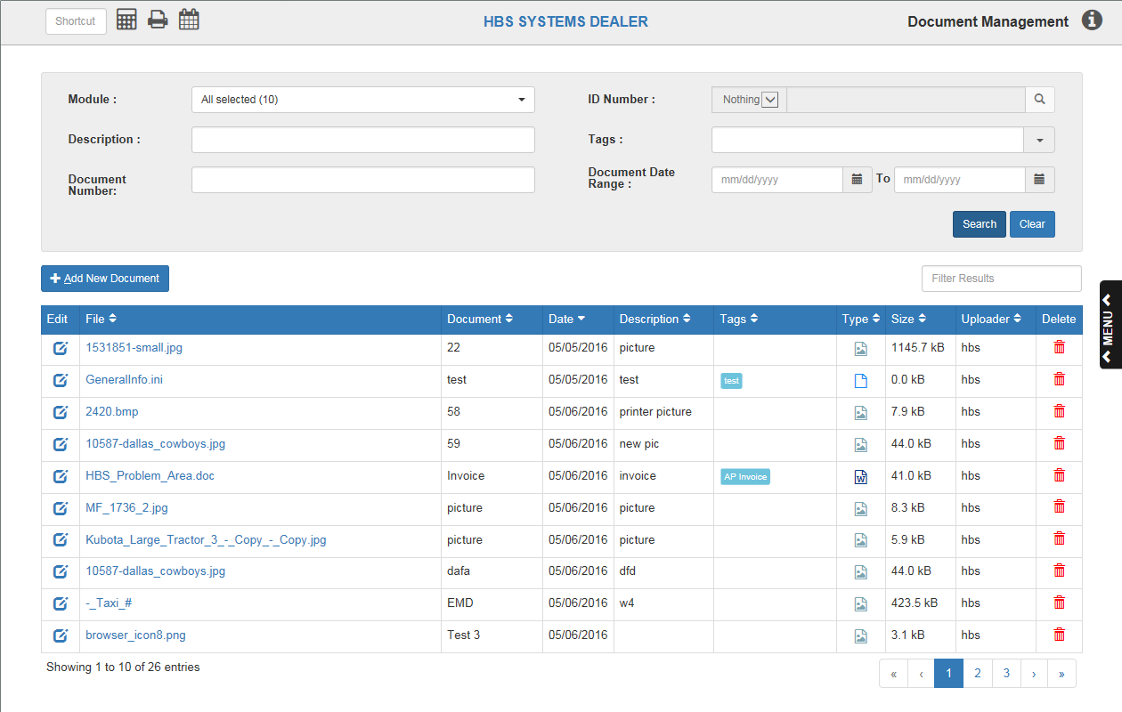

**Document Selection:** The search results appear in the lower half of the application screen. You can use the page numbers, filter bar, and sortable headers to locate your desired entry among them if you don’t see it on the first results page.

* **Page Numbers:** Use these to switch between pages of results.
  + Click on a number to jump to that page of results.
  + Use the single arrows let you move back (left) and forward (right) a single page.
  + Use the double arrows to move to the very first (left) and very last (right) pages of the results.
* **Filter Bar:** Type in parts of an entry, like its description, date, or a tag, to further narrow down your results.
* **Sortable Headers**: Click the column headers (defined below) to re-sort the entries in specific orders, depending on which header you use.

File: This column lists the file/document name. If the name is blue, you can click it to open the document. You can also right-click on the document to save it.

* Click the header to sort the results in **alphabetic** order by file name.
* Click it again to sort the file names in **reverse-alphabetic** order.

Document: This column lists the document number.

* Click the header to sort the results in **ascending** order by document number.
* Click it again to sort the numbers in **descending** order.

Date: This column lists the document date.

* Click the header to sort the results in **chronologic** order by date.
* Click it again to sort the dates in **reverse-chronologic** order.

Description: This column lists the document’s description, if any.

* Click the header to sort the results in **alphabetic** order by the first letter of the description.
* Click it again to sort the descriptions in **reverse-alphabetic** order.

Tags: This column shows any tags applied to the document.

* Click the header to sort the results in **alphabetic** order by the first letter of the first tag.
* Click it again to sort the tags in **reverse-alphabetic** order.

Type: The icons in this column indicate what type of file the document is. For example, a Microsoft Word document will have an icon of a page with a stylized “W” on it pictured in this column. Click this header to sort the files by type.

Size: This column shows the file’s byte size.

* Click the header to sort the results in **ascending** order by file size.
* Click it again to sort in **descending** order by file size.

Uploader: This column shows the user who uploaded the file.

* Click the header to sort the results in alphabetic order by uploader name.
* Click it again to sort the uploaders in descending order.

Delete: Click the red trash can icon in this column to delete the document from the system.

**Edit Document:** Click the blue icon in the **Edit** column to edit the document details in a new window.

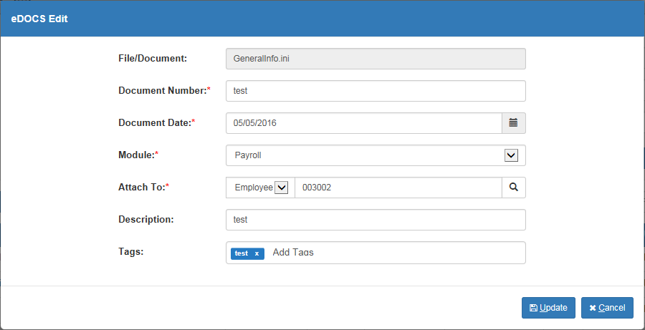

File/Document: This field shows the file/document name. This field is unavailable for editing at this time.

Document Number: Edit the document number here.

Document Date: Edit the document date here. You can also use the calendar icon to select a new date.

Module: You can change the module associated with the document by choosing a new module from the drop-down menu.

Attach To: Use these fields to change the ID number that the document is attached to, as well as the type of ID the document is attached to (depending on the module).

Description: Edit the document’s description here.

Tags: Add a new tag by typing it in this field and pressing “Enter.” Remove tags from the document by clicking the “x” on the right of the tag.

Update: Click this button to update the document in the system with your changes.

Cancel: Click this button to cancel any changes made before updating.